Analysis notes:

For trait \* env analyses, not calculating gower distance because they are all length.

CWM-RDA – exclusively community level trait analysis

Approaches

Weischer et al – assembling an ant community NMDS, then multiple response permutation procedure Fourth corner ade4 against a null model

Boet et al 2020, Plos one. The role of environmental vs. biotic filtering in the structure of European ant communities: A matter of trait type and spatial scale

Jaccard index co-occurrence for each pair of species in the matrix from a presence/absence matrix. Gower’s for pairwise species. But only calculated at the largest scale because it depends on the number of species.

“The relationship between the functional dissimilarity and the co-occurrence index between species pairs was tested by using linear models. Given the large number of zeros in the co-occurrence index and failure to meet the normal assumptions, we carried out the analyses in two steps. First, we transformed the co-occurrence index into a binary variable indicating whether or not there was occurrence of the pair of species in each matrix. We used a generalized linear model with a binomial distribution and a logit link function to perform the analysis (hereafter, binary co-occurrence analysis). In a second step, we applied a general linear model to make the model with the co-occurrence index where the pair of species occur at least once in the matrix (hereafter, co-occurrence strength analysis). In this case, the co-occurrence index was log-transformed to satisfy normality assumptions. We performed 18 analyses at the European scale (nine analyses for binary occurrence matrices and nine for co-occurrence strength matrices, these last nine comprising one analysis with all traits together, two analyses corresponding to each group of traits, and six analyses corresponding to each trait separately), 90 analyses at the biogeographic scale (forty-five for binary occurrence matrices and forty-five for occurrence strength matrices, of which nine analyses corresponded to each of the five biogeographic regions), and 333 analyses at the local scale (117 for binary occurrence matrices and 216 for co-occurrence strength matrices, comprising 37 analyses with all traits together, 37 for each group of traits and 222 for each singular trait). It is worth noting that binary co-occurrence analyses were only performed in locations where more than five pairs of species showed values of co-occurrence = 0. Generalized and general linear models were conducted using the ‘stats’ package in R.ested using binomial”

Camarota et al 2016 – Co-occurrence patterns in a diverse arboreal ant community explained more by competition than habitat

Calculate C-score for all pairs in the matrix, also pairs of species. Sorenson to measure the mean number of shared sites between the different pairs of species. Generated null models and calculated SES to determin significance of observed values. They then created habitat contrained and non-constrained null mode. Indicator species analysis. Logisiic regression of association (seg vs ag), does dissimilarity in traits predict association?

Ward and Beggs, 2007. Coexistence habitat patterns and the assembly of ant communities

Species richness, Chao 2 estimate. Composition NMDS using Bray-Curtis. The pariwise tests of island and habitat using ANOSIM.

Co-occurrence using ecosim – all species, habitats separated. SES for co-occurrence.

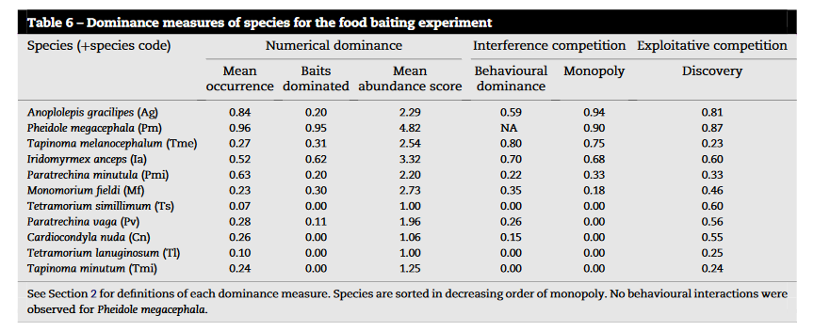

Fichaux 2019 – Habitats shape taxonomic and function composition of neotropical ant assemblages

Variation among habitats, CA, significance of Compositional differences – Permanova using adonis. Indicator species habitat. PCA to summarize trait data. Functional indices – Fric, FEeve, FDiv, FDis. Multid dimFD function, spearman rank correlations association between taxonomic and functional diversity indices. CWM for each trait. GLM with functional diversity as response and habitat is predictor. Partitioned beta diversity. Composition variation using jaccard pariwise. Used betapart.

Tested environmental filtering hypothesis by: comparing observed cuntional diversity metrics, evidence comes from functional evenness to a null model. Competitve exclusion – increase in function richness, divergence, dispersion, specialization and orginals. Kurtosis of trait values, copetitions = lower kurtosis than expected

Gibb – 2015. Does morphology predict trophic position and habitat use of ant species and assemblages? Oecologia Phylogenetic regression of traits and env. Fourth corner – trait.mod

Campbell and Crist 2017 – glm for each species separately. Ant-trap frequency. dbRDA for predictors of patch and landscape composition. Mantel tests for Euclidean distance and community dissimilarity.

Frenette-Dussault 2013

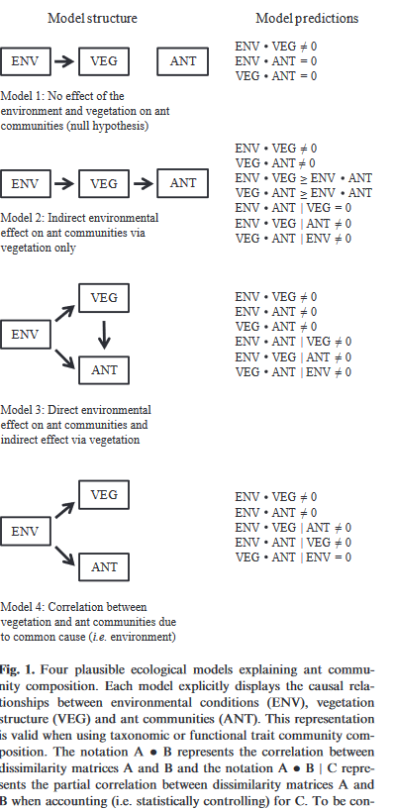

Causal relationship between enivornment, vegetation and ants – partial mantel correlations. Create dissimilarity matrices for each. Then repeated at the functional level by computing CWM for abundance. Fourth corner.

Sanders et al 2007 – C-scores and null models. SES. Body ratios by looking at body size ratios spaciing., copared ot null model.

Wong 2021 – To capture asymmetry in cooccurrence, calculated odds tratios. Compared to null model, SES. Traits – built species-level probability density functions to calculate trait probability distributions. Calculated AD as prop of species trait density function not overlaps with s. invicta.

